Guidance for Using Zoom
For those of you who have never used Zoom or are still figuring it out, we offer an orientation session at 5:00 p.m. on Tuesday, July 21. This will give us a good 30 minutes together so that you will feel more comfortable participating in the Community Forum at 5:30. If you have been wanting to participate in a Zoom meeting, now is a good time to learn!
You can use your desktop computer, laptop, iPad or other device or smart phone.
Step 1. Launch Zoom to enter the meeting.
  - In the meeting invitation, there should be a “live hyperlink” which you can click on. It will take you directly to the meeting. You may be asked for a password, which will be included in your email invitation. If asked for the password, copy it from the invitation and paste it into the “password” box. Or write it down and then type it into the password box.
  - There will probably be a “waiting room”, a holding area. The host will admit you into the meeting.
Step 2. Audio and Video – Zoom will attempt to start your speakers and webcam. This is just fine and you can let your device activate them. If you have problems, they may be due to your hardware (computer’s age, for example). We will walk everyone through a few steps to resolve the camera and speakers issues, hopefully!

Seeing everyone!
The little icon (usually on the upper right hand side of your screen) lets you adjust how you see other participants and speakers.
  - “Gallery view” will show you all the participants you can fit on one page.
  - “Speaker view only” shows you the person who is currently speaking.
  - This might be a bit confusing, because you’ll see Speaker View if you’re in Gallery View and vice versa. It’s a toggle – you’re in one or the other:
Below is an example of Gallery View (note that Terry is highlighted, as the current speaker). Depending on the device you’re using, and/or your bandwidth, participants will see a varying number of participants. If all the participants will not fit into your screen, you might see arrows on the sides enabling you to scroll through them.
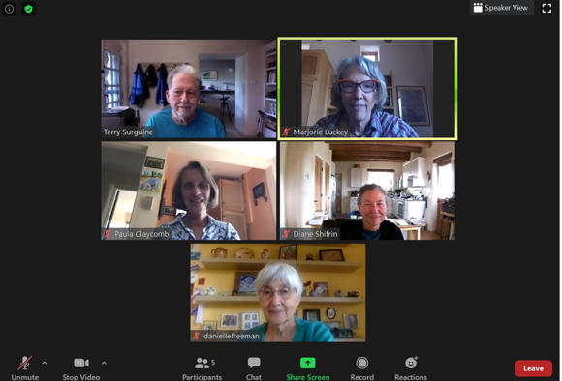

Muting / Unmuting:
- In the screenshot, all the participants have muted themselves, except Terry as the host. (See the red mic icon on the lower left corner of their images.) The host will sometimes mute all participants, but you have the option to unmute yourself when recognized to speak, by clicking on the microphone icon. Keeping your microphone muted unless you are speaking helps cut down on extraneous noise!
To speak during the forum
  - To indicate you wish you wish to speak, raise your (real life) hand. We’ll be watching for you.
  - There is a function in Zoom that allows participants to raise their “virtual” hands, but we think this might be too complicated for our first Community Forum via Zoom!

Chat
- If you click the Chat button at the bottom of your screen, a window will open up on the right. Here, you can type in or paste information to Everyone, or, privately, to a Participant. Use the pull-down menu to see other participants.
- You can send a chat message to EVERYONE, as shown, OR send a private message to a single participant, by using the pull-down menu.
- You can cut and paste text or links into Chat.
Leaving the meeting
a. Look for a RED BUTTON that says “LEAVE”. Depending on your device, it may be in the upper left hand corner or the lower right hand corner of your screen.
b. You might be prompted with another red button that says “LEAVE MEETING”. If you clikc on it, you are well and truly out of the meeting!

A few troubleshooting tips
Troubleshooting Speaker Issues
- Ensure your speaker is turned on. ...
- Increase the volume on your mobile device using the volume buttons or notification panel. ...
- Try using earphones.
- Restart your mobile device or computer.
- Reinstall Zoom from the Apple App Store or Google Play.

Troubleshooting Microphone Issues
If you experience issues using your microphone with the Zoom mobile app, try these tips:
- Ensure the microphone is not on mute. If you see the muted Audio icon in the meeting controls, tap it to unmute yourself:
If you are still muted, the host may have muted you upon entering the meeting. Ask to be unmuted by sending a chat message to the host.
- Ensure you have connected your mobile device's audio. If you see the following Audio icon in the meeting controls, tap it and select Call via Device Audio. If prompted, allow Zoom to access your microphone.
- Try using earphones with a microphone.
- Ensure Zoom has access to your device's microphone.
- iOS: Go to Settings > Privacy > Microphone and switch on the toggle for Zoom.
- Android: Go to Settings > Apps & notifications > App permissions > Microphone and switch on the toggle for Zoom.
- Ensure that no other applications are using the microphone at the same time.
- iOS: Double-tap the "Home" button to view apps currently running. Swipe up to close an app.
- Android: Tap the multi-task button (the square icon usually in the bottom-right corner) to view apps currently running. Swipe left of right to close an app.
- Restart your iOS device.
- Reinstall Zoom from the Apple App Store or Google Play

