A CONVERSATION WITH STATE SENATOR GONZALES
Your chance to move New Mexico forward in the 2021 Legislative Session

Town Hall (via Zoom) with State Senator Roberto “Bobby” Gonzales
January 5th, 2021- 6-7:30 PM
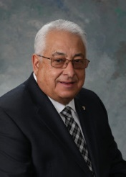

Registration required: tiny.cc/townhallnm
Info: 2021 LEGISLATIVE ISSUES
Submit questions in advance: IDYLLD@gmail.com
FB Event announcement: https://www.facebook.com/events/221102302962097

Co-hosted by Residents of NM Senate District 6, Taos United:Taoseños Unidos, Taos County Democratic Party , Taos Progressives and others

